***Plasma Ball***

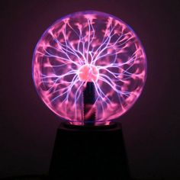

*Plasma ball uses 220V electricity. The base is made of plastic, the ball is made of glass. From the center of the sphere beautiful rays of light are continuously emitted. And when you touch any point with your hand. Anywhere on the sphere, the rays will immediately focus at the tip of your finger and it is very attractive as if you were controlling the electric current with your own hands*